

**SHRI VAISHNAV VIDHYAPEEETH VISHWAVIDHYALAYA**

**SVIS**

***PROJECT REPORT***

**SESSION: 2024-2025**

PROJECT NAME**:** CAB CONNECT (CAB BOOKING WEBSITE)

GROUP 12: B.SC (C.S.) SEC-A

SUBMITED TO: **DR. REENA GUPTA MAM &**

**PROF. ANIL KUMAR SIR**

SUMITED BY:

**HITAV JAIN**

**TEJAS SINGH**

**ABHISHEK PATEL**

**MAHI KUSHWAH**

**KULDEEP AANJANA**

1. **INDEX**
2. Title page
3. Index Page
4. Motivation
5. Introduction of the project
6. Description of Project Module
7. Static/Dynamic Features of project
8. Diagram
   1. ER diagram
   2. DFD
   3. Sequence / Activity Diagram
9. User Interface
10. Database Table
11. Limitations of the project
12. Future Scope
13. Result/ conclusion
14. Reference
15. **MOTIVATION**

In today’s digital era, most services have moved online to offer users better convenience and efficiency. However, long-distance cab booking, especially in states like Madhya Pradesh, still remains largely offline and disorganized. Travelers often struggle with finding cabs on time, unclear pricing, and the need to visit physical booking counters.

**Cab Connect** aims to solve these problems by automating intercity cab bookings across Madhya Pradesh. The platform offers a simple, user-friendly interface where users can check cab availability, estimate fares, and confirm bookings—all without middlemen. This helps make the process more transparent, reliable, and time-saving.

Inspired by the need to simplify intercity travel, Cab Connect focuses on accessibility and affordability. It ensures that people can travel between cities with ease, comfort, and fair pricing. By bringing long-distance cab booking online, Cab Connect hopes to revolutionize travel across the state.

1. **INTRODUCTION OF THE PROJECT (PROBLEM STATEMENT)**

The existing cab services either focus on short-distance city travel or operate without proper structure in rural or intercity routes. Travelers face multiple issues:

1. No easy way to book a cab online for long-distance within Madhya Pradesh.
2. Pricing is not transparent, and haggling is common.
3. No digital receipts or summaries are available.

**Cab Connect** addresses these issues by offering a centralized platform that allows users to:

1. Enter pickup and drop locations manually.
2. Select from different cab types.
3. Get fare estimates based on distance and cab type.
4. Generate and view a summary and receipt after booking.

This simplifies the experience and brings structure to the long-distance travel booking process.

1. **DESCRIPTION OF PROJECT MODULES**

1. Sign Up Page: The Sign-Up Page allows new users to register on the platform. Users are required to enter their full name, email address, mobile number, and a secure password to create an account. Basic form validations are implemented to ensure data accuracy and security. Upon successful registration, users are redirected to the Sign In page to access their personalized dashboard.

2. Sign In Page: The Sign-In Page provides returning users with access to their accounts using registered email and password. The system verifies credentials against stored records and grants access only if authentication is successful

3. Home Page: The Home Page is the main interface where users can initiate a new cab booking. It includes input fields for pickup and drop-off locations, date of travel and distance. The Home Page also provides quick links to other features like logout.

4. Bookings Page: The bookings page presents users with a variety of cab options to choose from after they enter their pickup and drop-off locations. The available car types are displayed clearly, allowing users to compare and select the most suitable vehicle for their journey.

Displayed Cab Types:

1. Mini – Budget-friendly option, ideal for 2–3 passengers.
2. Sedan – Comfortable and spacious, suitable for small families.
3. SUV – Larger seating capacity and luggage space, good for group travel.

Each car option is displayed in a card or list format, including:

1. Cab Image or Icon
2. Name of the Cab Type
3. Fare

5. Summary and Details Page: After the user enters all trip details and selects a cab, the Summary and Details Page shows a detailed overview of the ride. It includes the selected cab type, route, estimated distance, total fare. Users can confirm or go back to make changes.

6. Payments Page: The Payments Page handles the final step before booking confirmation. It offers different payment methods (such as UPI or cash). Once the user selects a payment option and completes the transaction (or chooses to pay later), the booking is finalized.

7. Receipt Page: The Receipt Page generates a digital confirmation of the booking. Users can download or print the receipt for their records.

1. **STATIC/DYNAMIC FEATURES OF PROJECT**

1.Static Features

These are non-interactive, informational pages that provide essential content to users:

1. Home Page: Introduces users to the Cab Connect platform. It provides an overview of services, a call-to-action for booking cabs, and quick links to other sections.
2. About Us: Shares the mission, vision, and purpose behind Cab Connect. It explains the problem the platform aims to solve and highlights the benefits of the service.
3. Contact Us: Contains contact information such as email ID, phone number, and possibly a contact form for user inquiries, complaints, or feedback.

2.Dynamic Features

These features involve backend interaction and user-specific actions that change data or content on the website:

1. User Login and Registration: Allows new users to register and existing users to sign in using credentials. Ensures secure access to personalized features like booking history.
2. Location Input and Distance Calculation: Users enter their pickup and drop-off locations. The system calculates the distance between them, either manually or through integrated APIs.
3. Fare Estimate: Based on selected cab type and calculated distance, the system displays the estimated fare instantly, improving price transparency.
4. Cab Selection and Booking: Displays a list of available cabs (Mini, Sedan, SUV, Luxury). Users can select one, view the ride summary, and confirm the booking.
5. Receipt Generation: Once a booking is confirmed, the platform generates a downloadable and printable receipt with booking details and fare breakdown.
6. **DIAGRAMS**

**7.1 ER DIAGRAM**

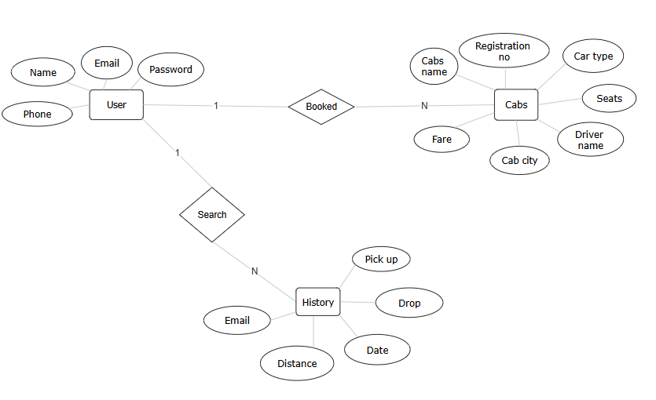

* 1. **DFD DIAGRAM**

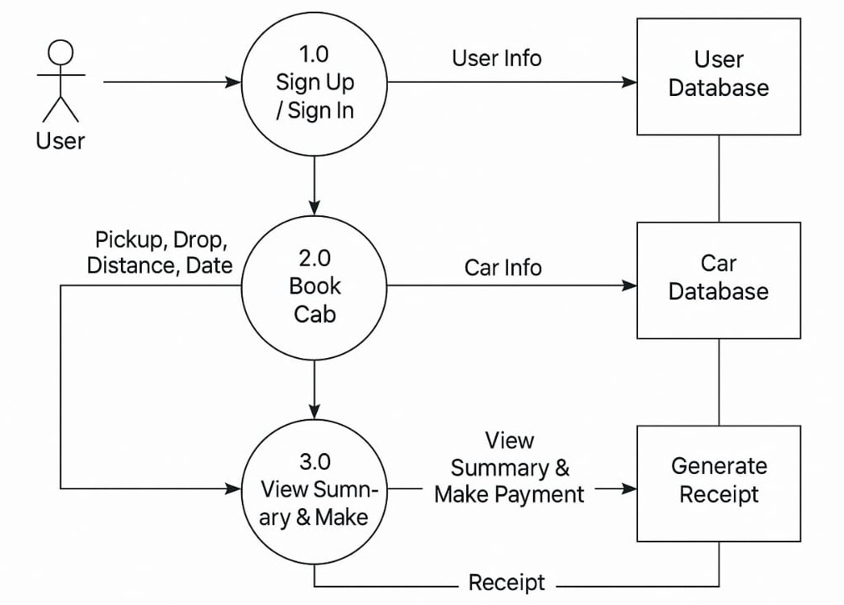

* 1. **SEQUENCE DIAGRAM**

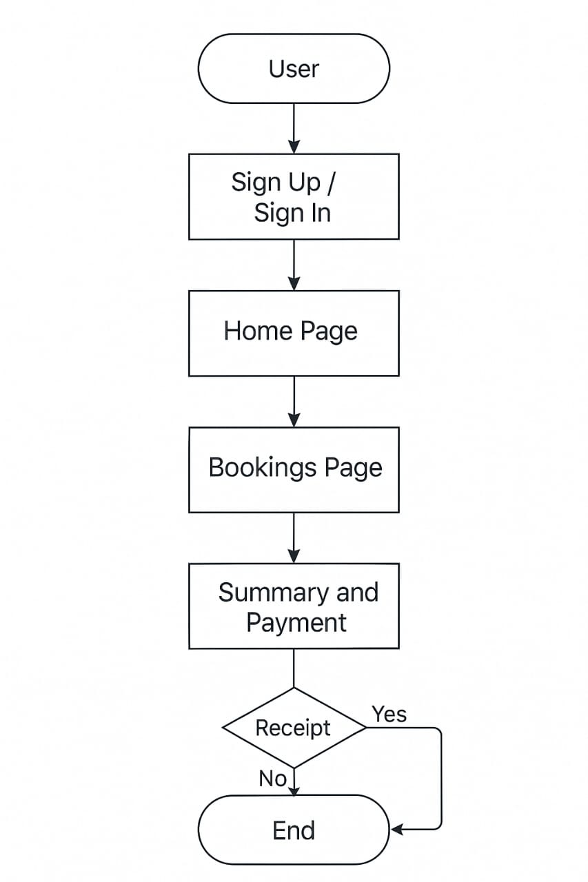

1. **USER INTERFACE**

The user interface (UI) of **Cab Connect** is designed to be clean, intuitive, and user-friendly, ensuring a seamless booking experience for all users. Every component of the interface focuses on simplicity and accessibility to cater to users of varying digital proficiency levels.

Key UI Features:

1. Clean and Minimalist Design: The layout is simple, with clear sections and minimal clutter, helping users focus on essential tasks like booking and viewing details.
2. Manual Text Inputs for Locations: Users enter pickup and drop-off locations manually via input fields. This provides flexibility for typing any town or city within Madhya Pradesh, rather than being restricted to dropdowns.
3. Card-Based Layout for Cab Selection: Different cab types—Mini, Sedan, SUV—are displayed as separate cards. Each card includes an image, fare, allowing easy comparison and selection.
4. Booking Summary Section: Before confirming a booking, users are shown a clear summary including:
   1. Selected cab type
   2. Seating capacity
   3. Distance
5. Contact and Support Section; Easily accessible section for reaching out to customer support. Includes phone number, email.

1.Sign up page

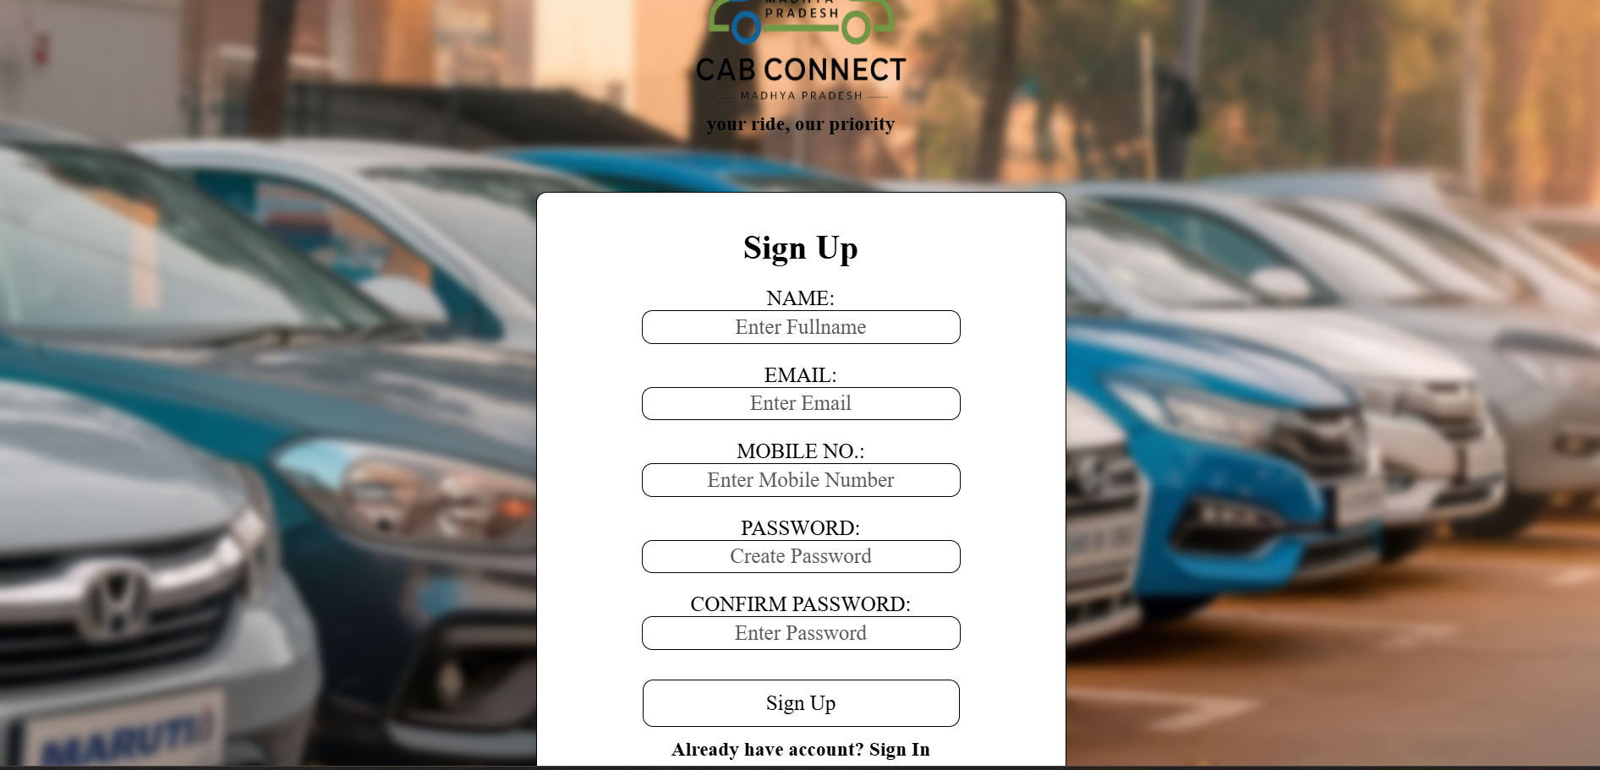

2.Sign in page

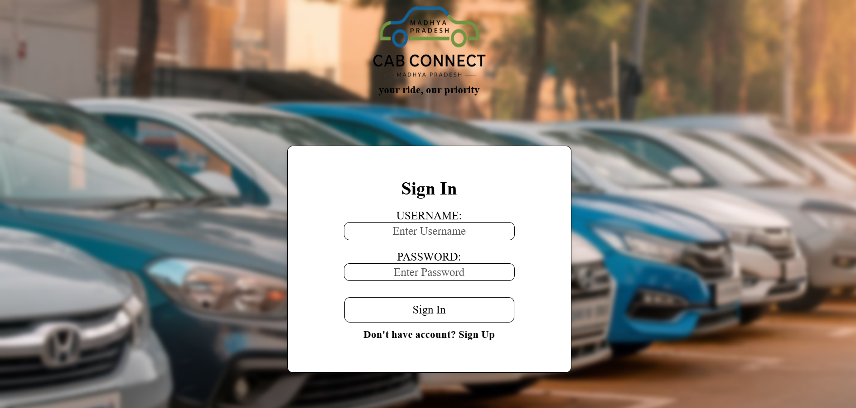

3.Booking page

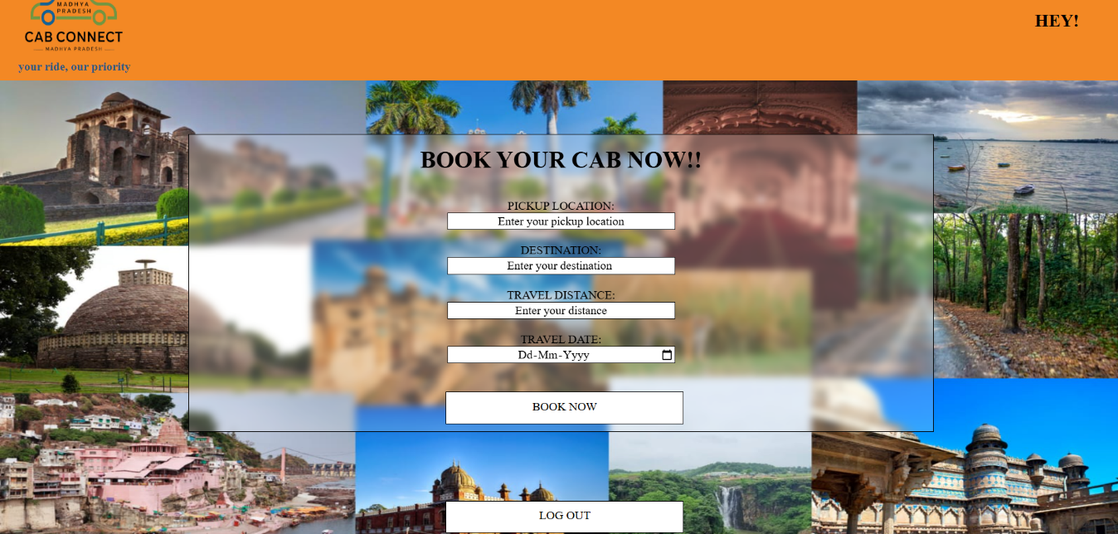

1. Bookings

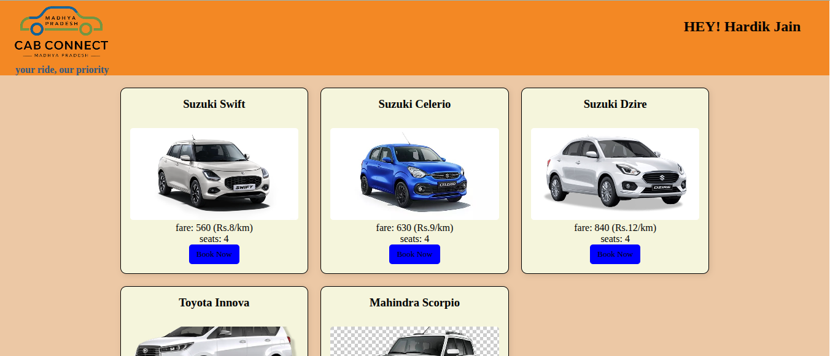

1. Summary

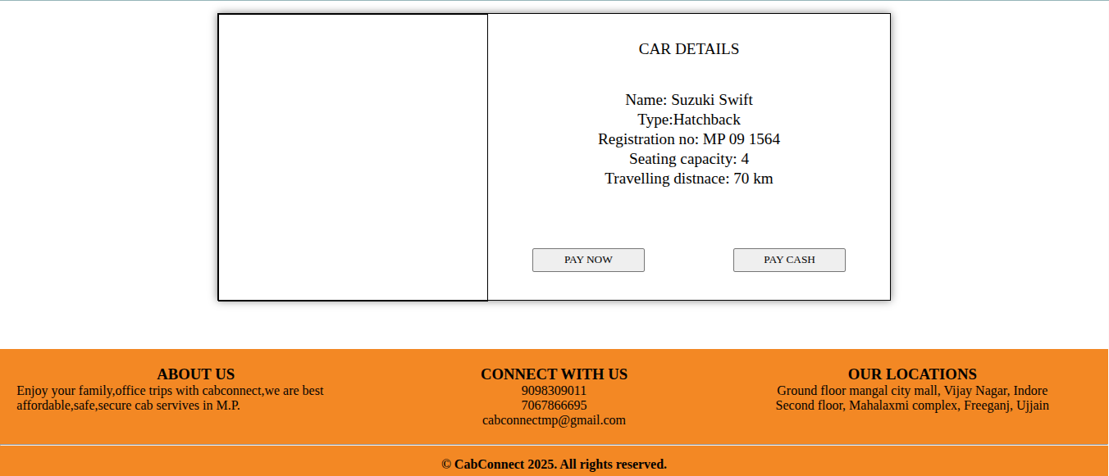

6.Receipt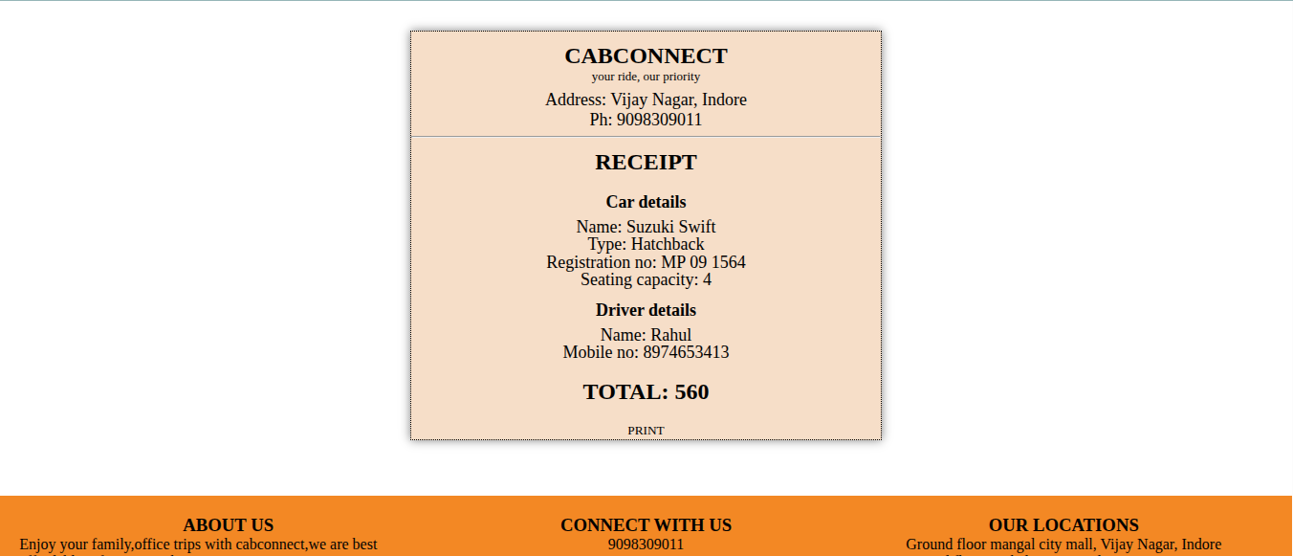

1. **DATABASE TABLES**

1. User database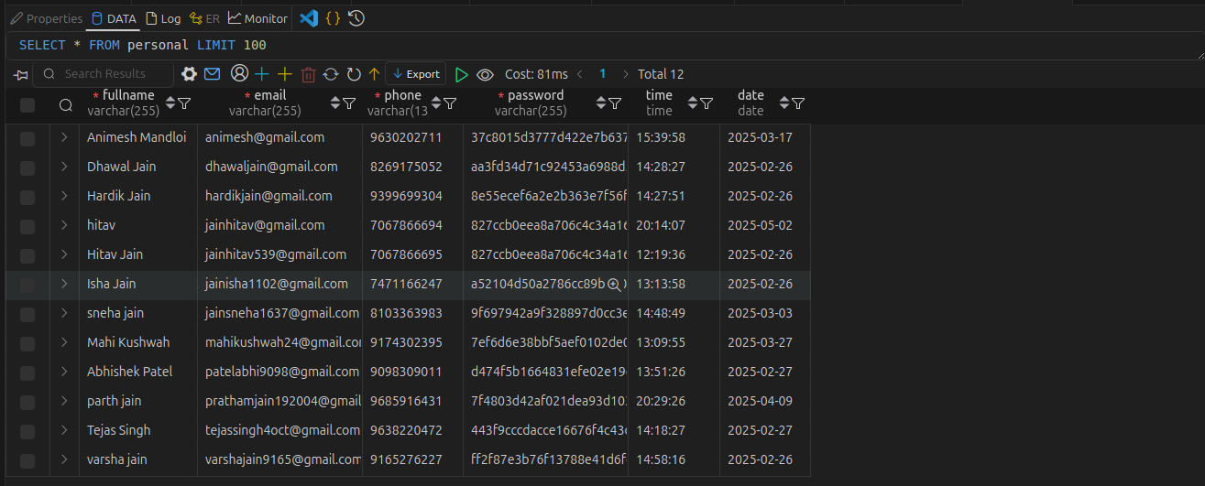

2. Cab database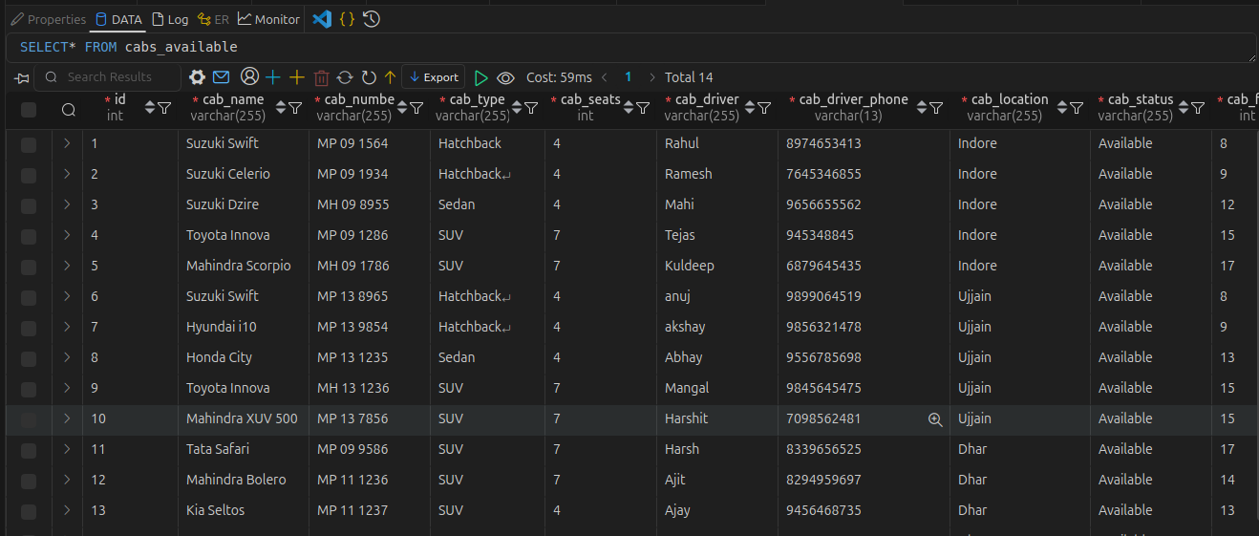

3. History database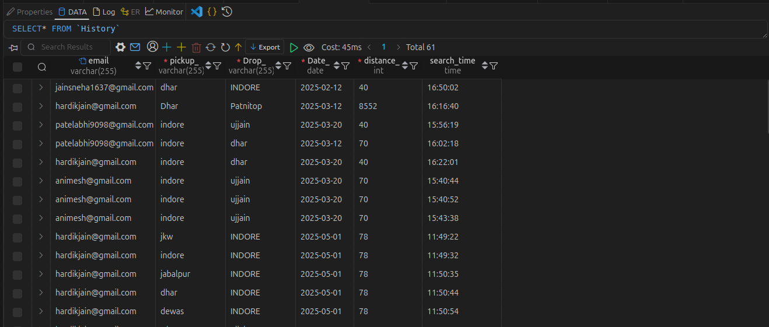

1. **LIMITATIONS OF THE PROJECT**
2. No Live Cab Tracking: Users cannot track their cab’s real-time location after booking, leaving them unaware of the cab's status.
3. Manual Location Input without Google Maps Integration: Users must manually enter their pickup and drop locations, which can lead to errors and inconvenience.
4. Only Cash Payment Available (No UPI or Razorpay Yet): Currently, only cash payment is available, limiting convenience for users who prefer digital payments.
5. No Separate Driver Login or Assignment Feature: There is no system for assigning drivers to specific trips, nor can drivers log in to see their assigned trips.
6. Static Cab Availability, Not Updated in Real-Time: The availability of cabs is static and doesn't reflect real-time status, potentially leading to inaccurate information.
7. Cannot Change or Cancel a Booking Once Confirmed: Once a booking is confirmed, users are unable to change or cancel it, offering no flexibility for users who may need adjustments.
8. No 360-Degree View of the Car in the Summary and Payment Pages: Users cannot view the car they are booking, including its model. Adding a 360-degree view or images of the car would help users evaluate the car before confirming the booking and making payment.
9. Receipt not printable yet: Currently, the system generates a receipt after booking, but there is no option to directly print or download it.
10. **FUTURE SCOPE**
11. Payment Gateway Integration: Adding Razorpay, PhonePe, UPI, and Net Banking options for digital payments will provide users with more flexibility and convenience, enhancing payment ease and reducing reliance on cash.
12. Google Maps API Integration: Integrating Google Maps API for dynamic distance calculation and route display will ensure accurate location-based services and allow users to visualize routes, improving booking efficiency.
13. Driver Panel: A Driver Panel for logging in, accepting rides, and updating availability will streamline driver operations, improving booking management for both drivers and users.
14. Mobile App Development: A mobile app will make it more accessible for users to book, pay, and track rides from their smartphones, offering a user-friendly experience and additional features like push notifications.
15. Ride Cancellation or Rescheduling: Offering options to cancel or reschedule bookings will provide flexibility, accommodating changes in users’ plans and giving them more control over their bookings.
16. Review & Rating System: A review and rating system will allow users to rate their rides and services, improving transparency, providing feedback for future improvements, and helping others make informed decisions.
17. Printable receipt: Future updates will allow users to download and print professional booking receipts for official use and record-keeping.
18. Real-time Availability System: A real-time availability system will update cab status (booked/available), ensuring users only see available cabs, preventing double bookings, and improving the booking process.
19. **RESULT**
20. User Registration and Login: Allows users to create an account or log in to manage bookings.
21. Location Input: Users can manually enter pickup and drop locations for accurate fare estimation.
22. Cab Type Selection: Users can choose from available cab types, such as Mini, Sedan, SUV, or Luxury.
23. Real-time Fare Calculation: Provides an instant fare estimate based on distance and selected cab type.
24. Booking Summary: Users can view a detailed summary of their booking, including fare, cab details, and locations before confirming.
25. Booking Receipts: After confirmation, users receive a booking receipt that can be printed or saved for future reference.
26. **REFERENCE**
27. W3Schools (HTML, CSS, PHP)
28. Razorpay Developer Docs (for future payment integration)
29. Stack Overflow (for PHP-MySQL support)
30. GeeksforGeeks (Project Tutorials)
31. inDrive website (for ideas)

**************